Instructions for Focus POS Semi-Integrated with PAX S300 Terminal
Enter items into the Focus register like normal.
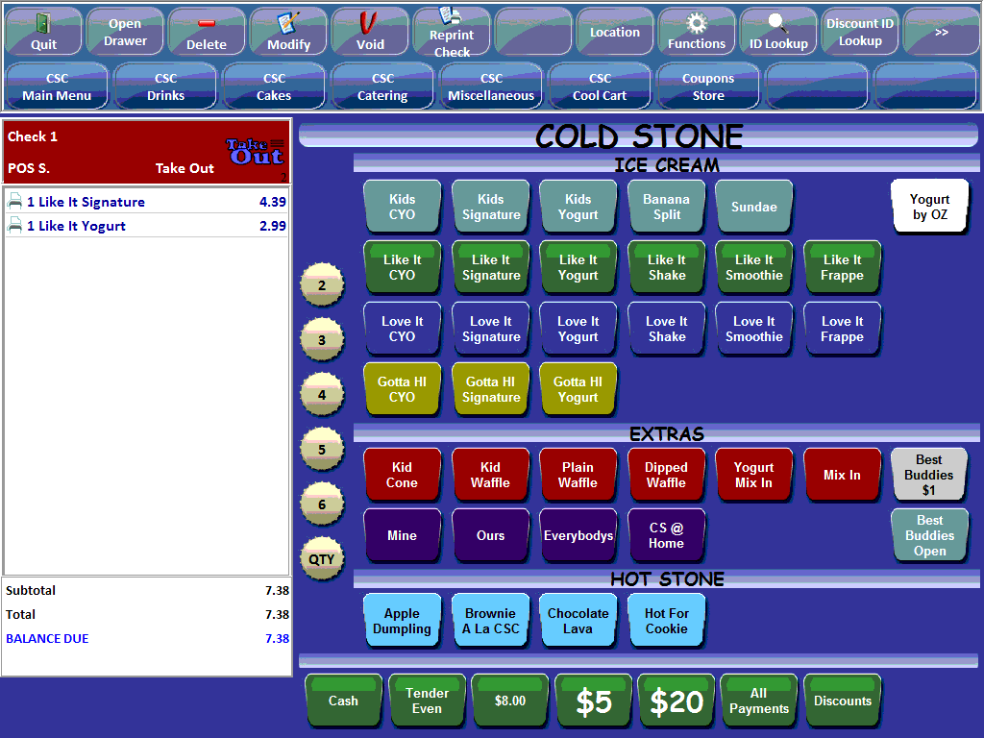

If a customer decides to pay with a regular credit or EMV chipped card, go to the All Payments screen and press either the EMV card button at the top of payment screen or at the bottom where the fast keys are located.

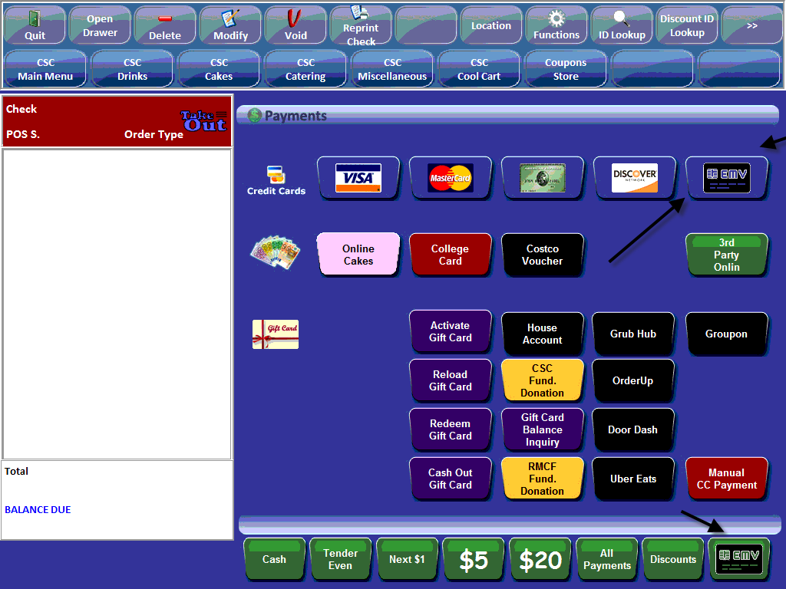

*****PLEASE MAKE SURE CUSTOMER DOES NOT INSERT EMV CHIPPED CARD UNTIL AFTER YOU HAVE PRESSED OK ON THE PAYMENT DUE SCREEN****

The Payment Due will appear on the screen verify the amount then press OK

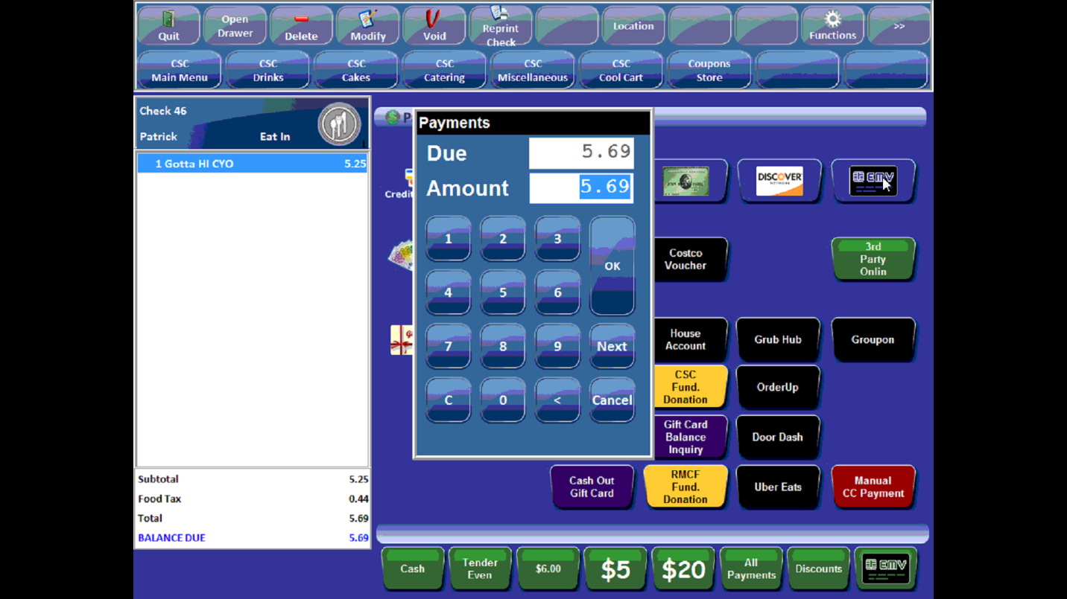

*****PLEASE MAKE SURE CUSTOMER DOES NOT INSERT EMV CHIPPED CARD UNTIL AFTER YOU HAVE PRESSED OK ON THE PAYMENT DUE SCREEN****

The screen will display Verifying while you instruct the customer to swipe or insert the credit card into the PAX S300.

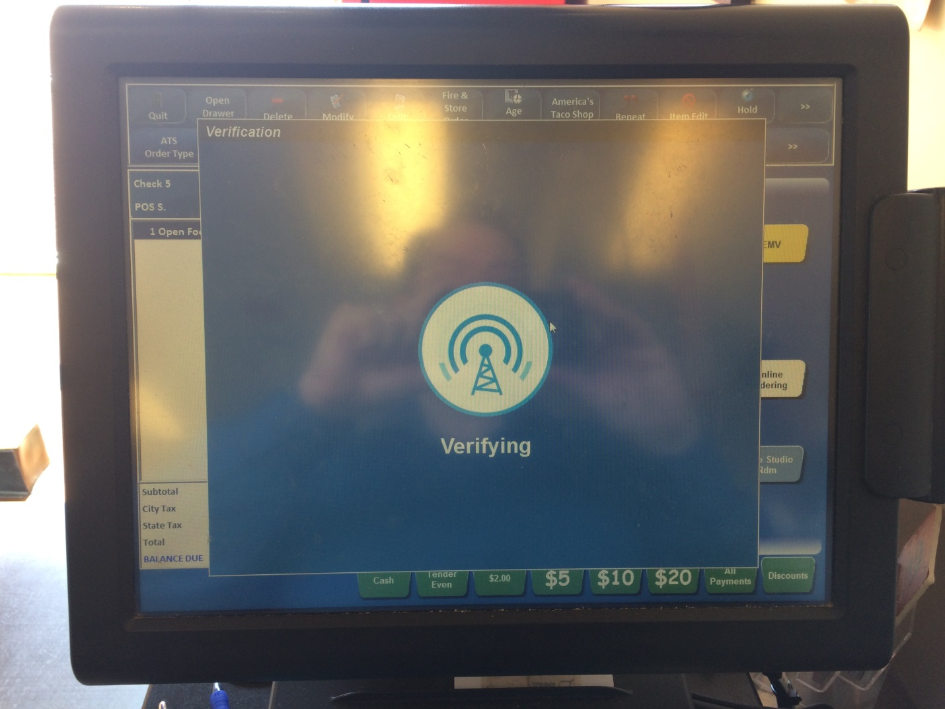

In order to process regular striped credit cards on the PAX S300, swipe on right the side of the device towards you with the magnetic strip facing the terminal.

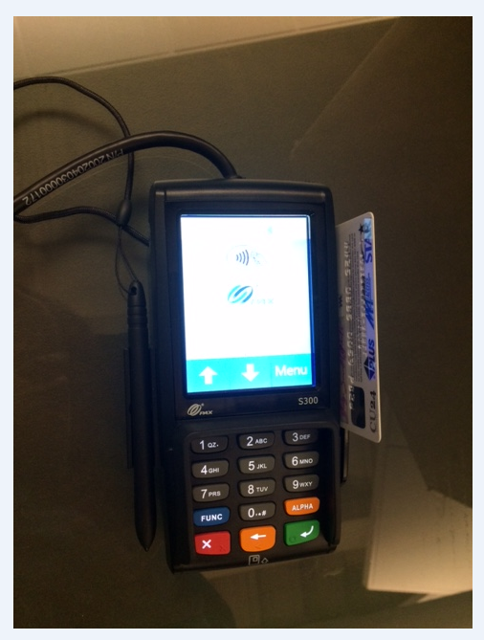

The PAX screen below will appear to the customer. At this time the customer can enter a tip amount or press the green enter button for no tip.

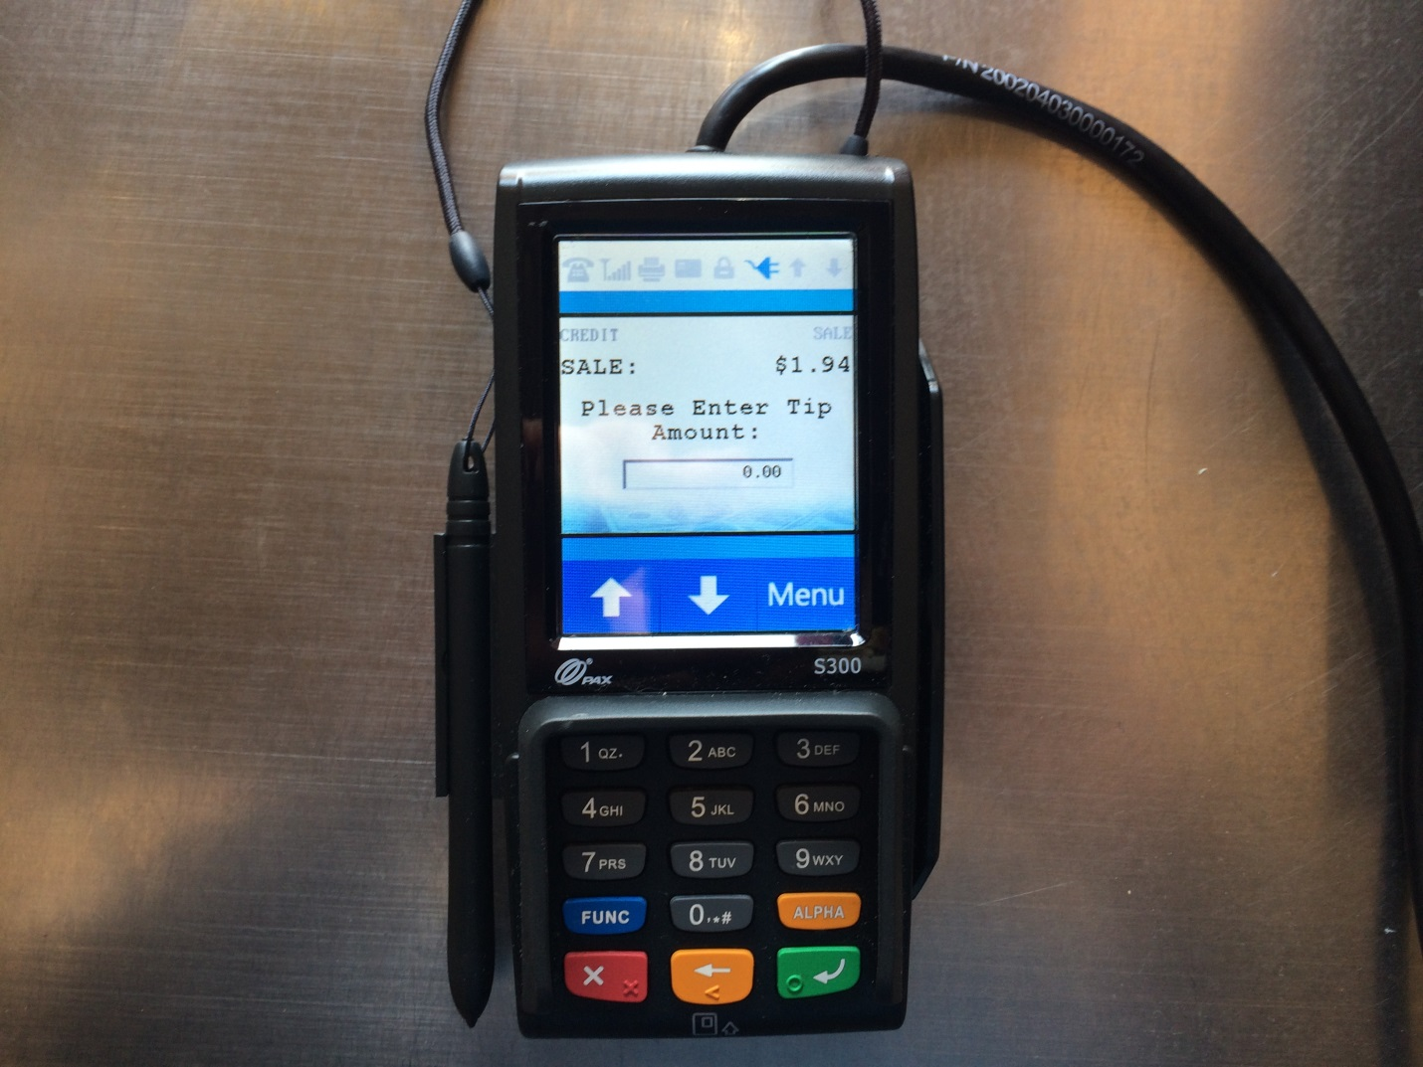

Once the tip amount has been entered, the PAX will prompt for inserting or swiping a credit card. Now have the customer insert or swipe card
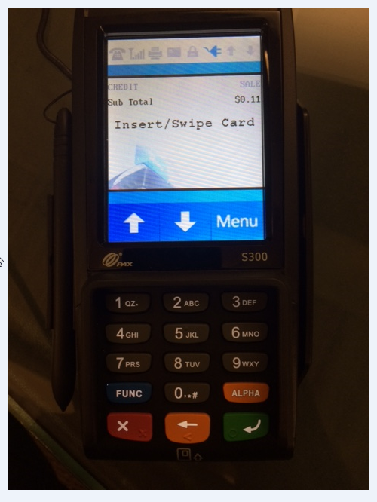

For EMV chipped cards, use the EMV reader at the bottom of the PAX S300.
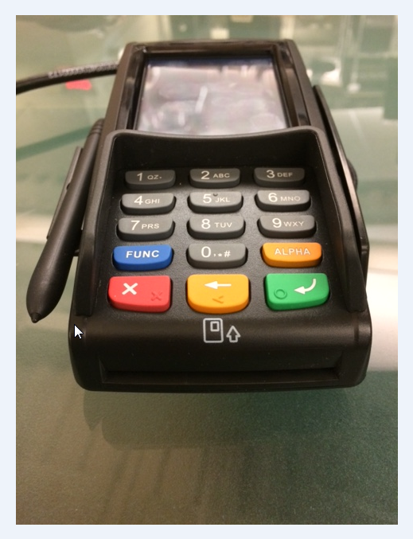

***If the magnetic swipe is not working on a NON EMV chipped card, you can manually enter the credit card. Start entering the numbers by pressing the key pad. Once you enter the credit card number press the green enter button, the PAX will then prompt you to enter the expiration date (MM/YY), CVV, address (zip code only) and Zip code again. After each entry is entered press the green enter button to process the card.***
Leave the EMV card in the PAX S300 until the device prompts you to remove the card.

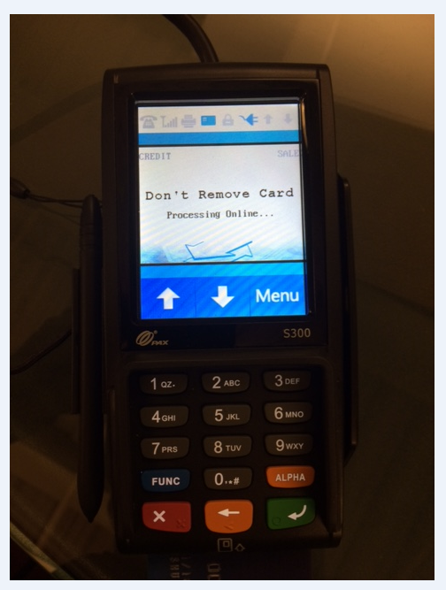

Once the card authorizes and approves the transaction, the device will prompt you to remove the card.
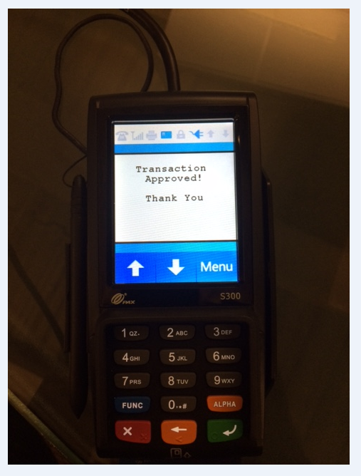

The screen will display Remove Your Card. 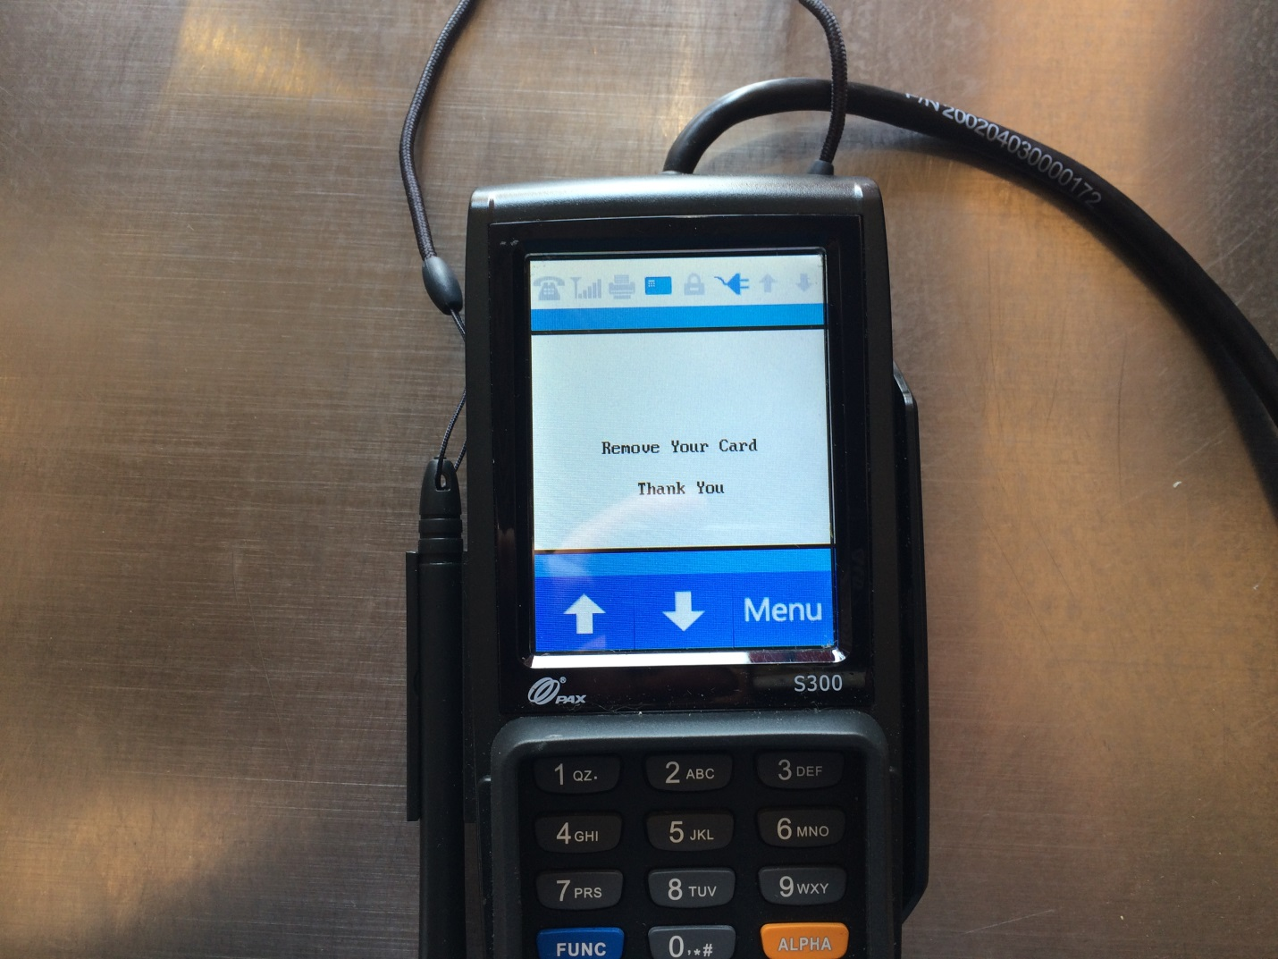

On the register screen an approval code will appear with a Done button. Press the Done button and at that time the detail receipt, customer signature copy, and merchant copy will print on the receipt printer. Please distribute accordingly and make sure you get the signed merchant copy for the cash drawer.

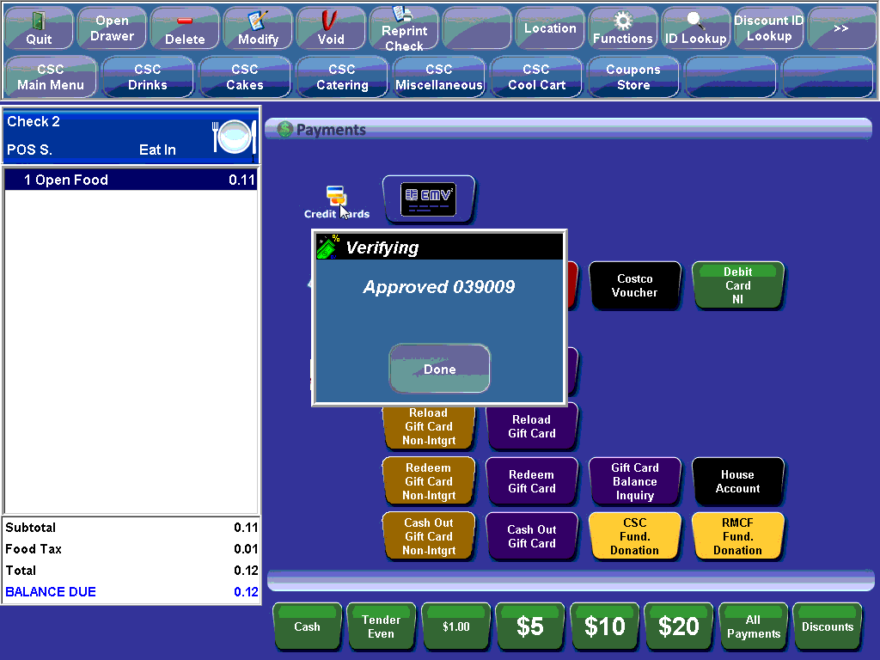

If for some reason the credit cards didn’t batch prior night on the PAX S300 a manual close batch will be needed. Please call the Helpdesk 1-877-811-3811 for assistance and ask for Jerry Somerville-Shull.

***BELOW IS FOR MANAGERS ONLY***

To verify if credit card batch closed successfully Press Function and 1 on the PAX terminal at the same time, the terminal will require a password. That password will be the current day’s date in the following format MMDDYYYY EX: 07182017 then press the green enter button.

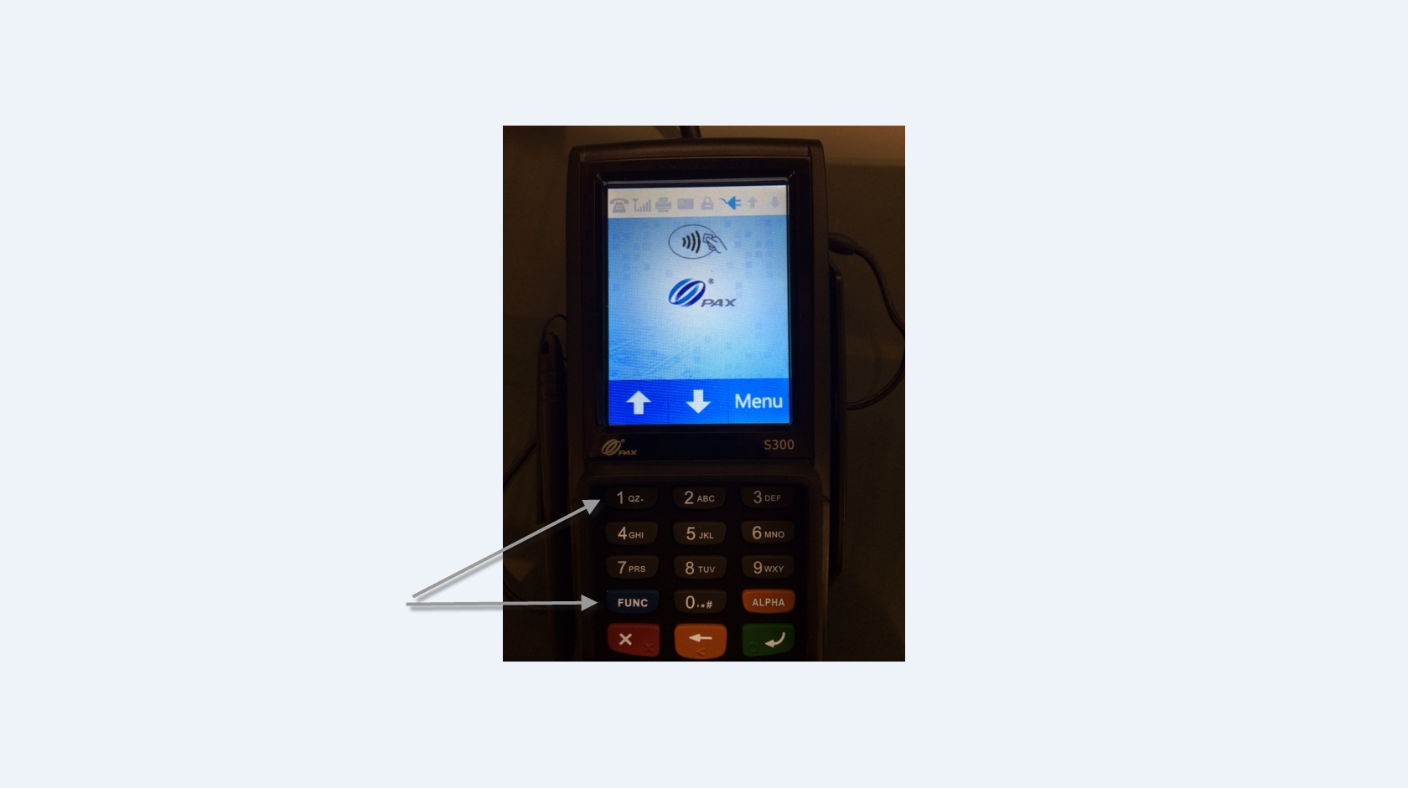

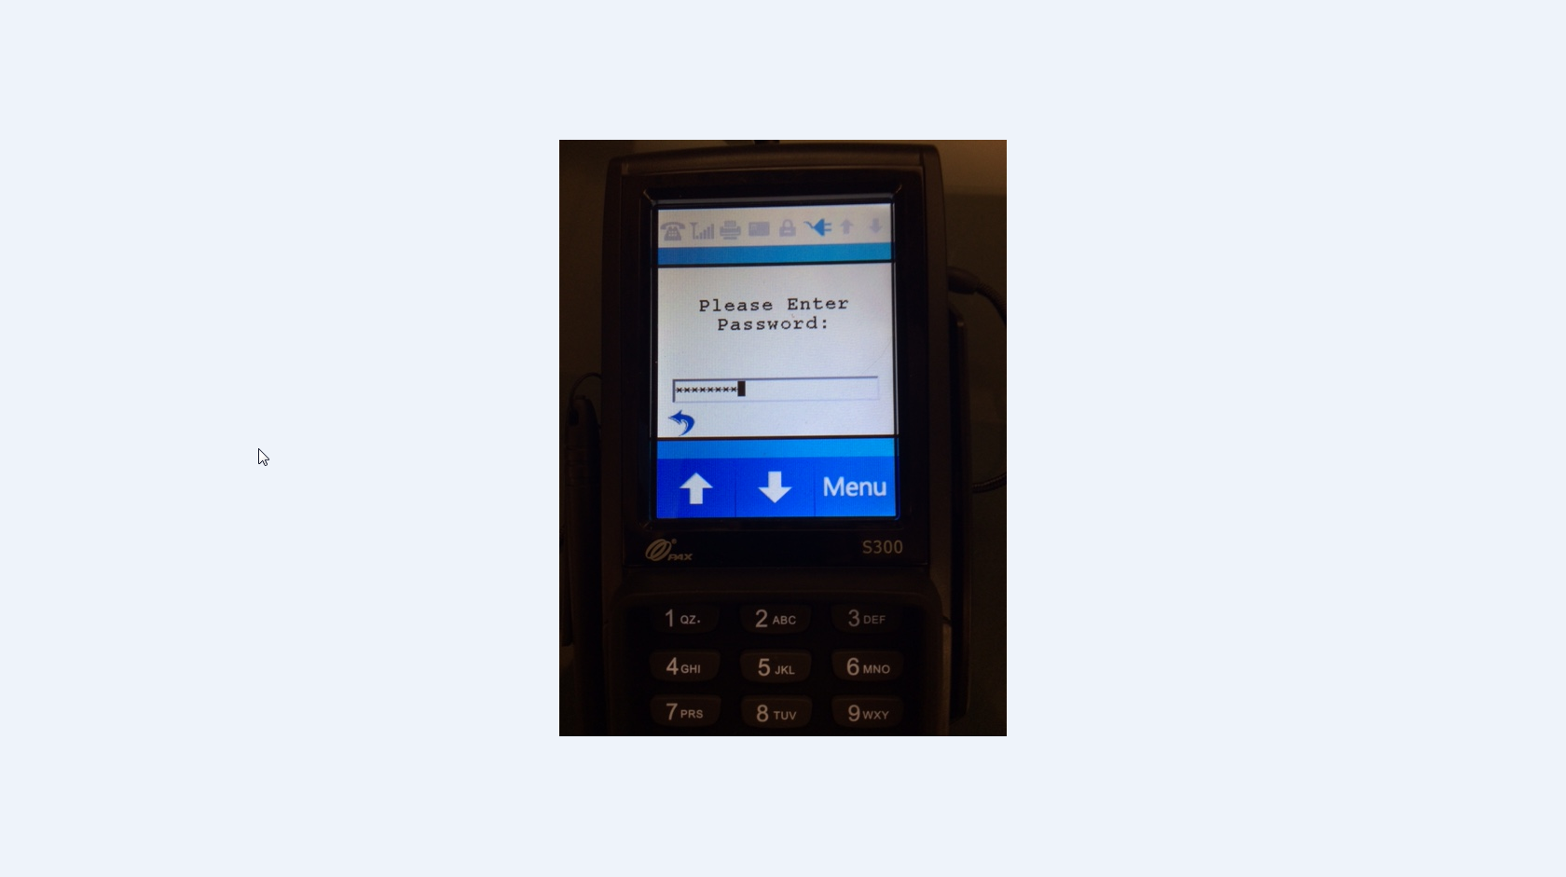
There will a button on the touch screen that displays the words Display Transactions with the number of transactions. Press the Display Transactions button.
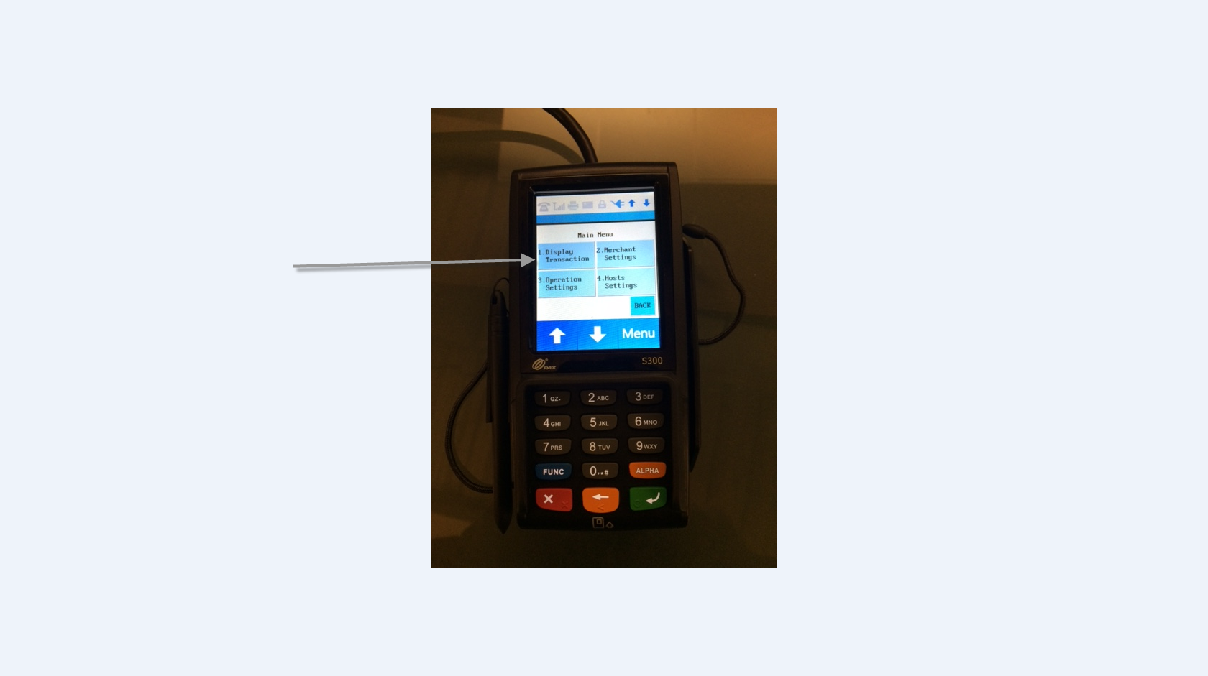

Press the Review button it will show you transactions on the screen if the credit card batch didn’t settle correctly.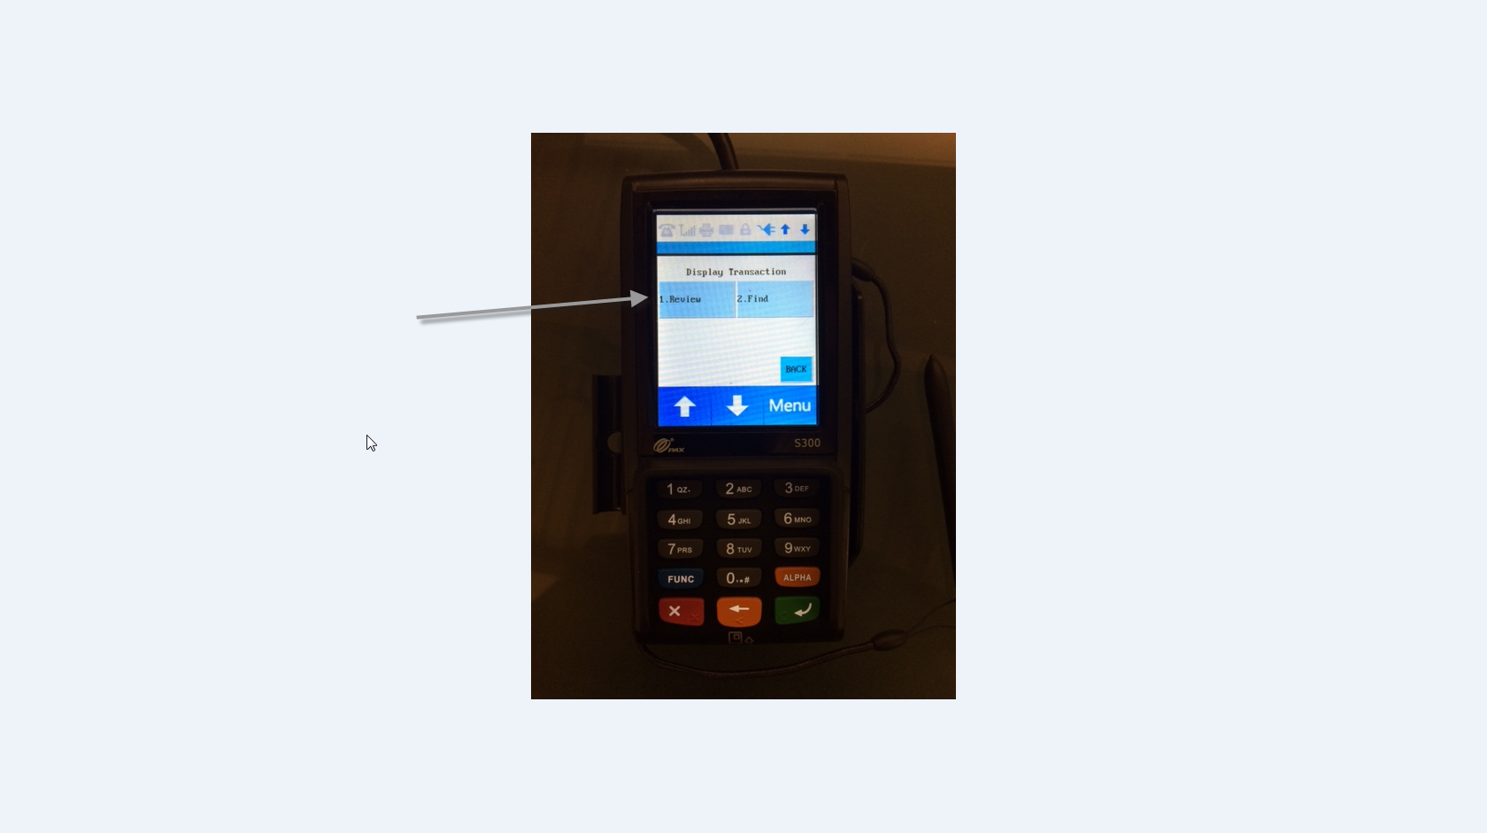
This will display the total in credit card charges.
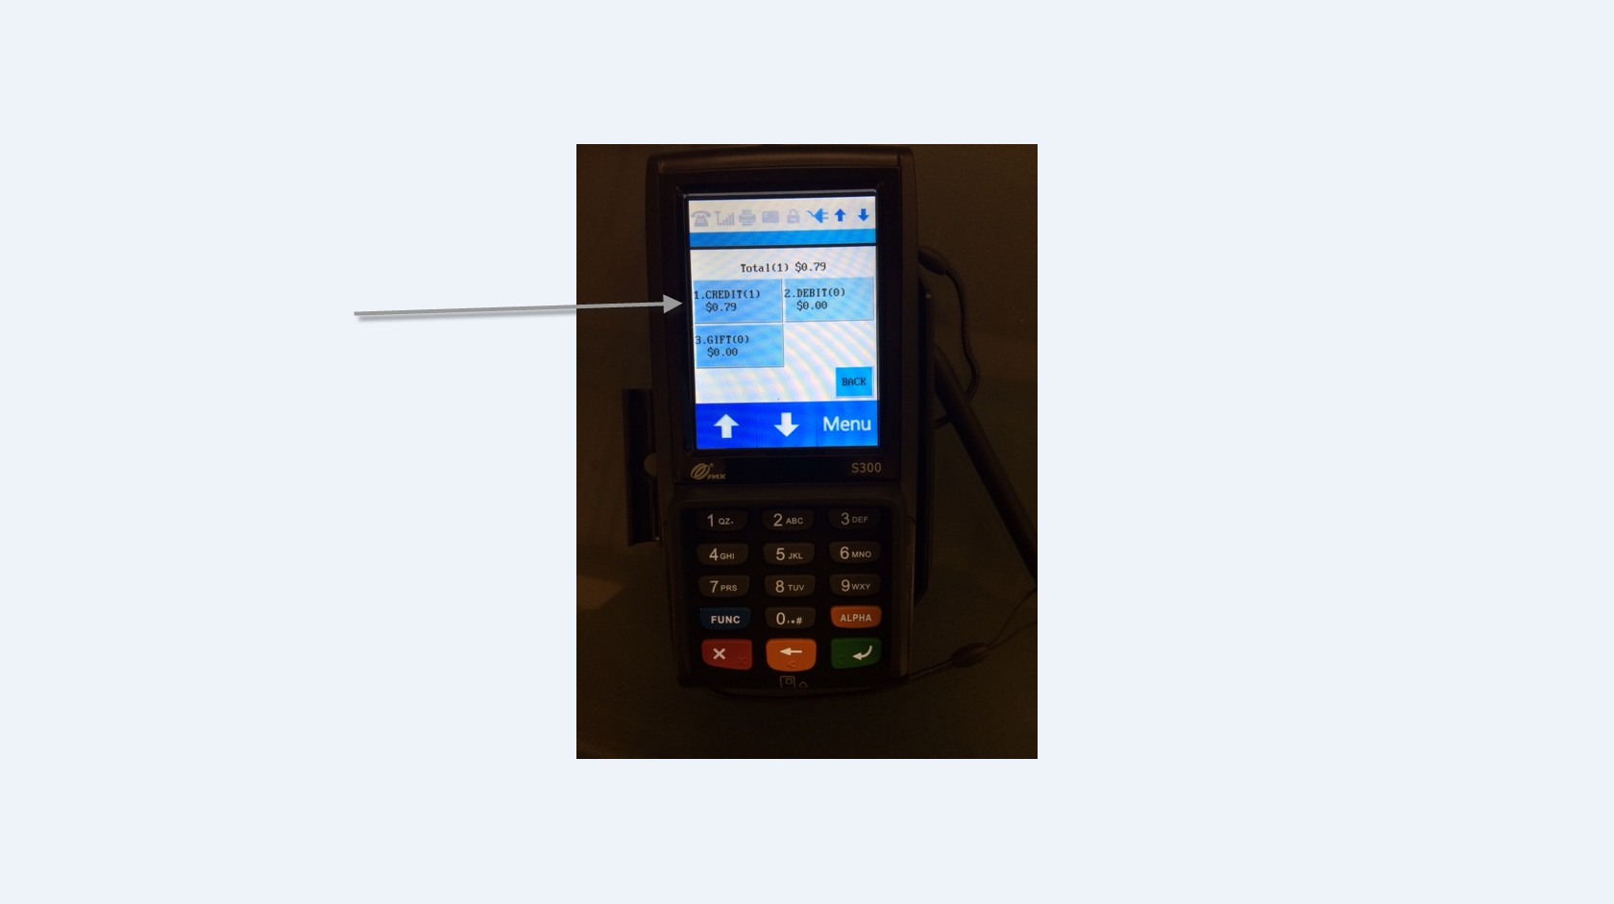

If you want to view the transactions in detail press the 1. CREDIT button.
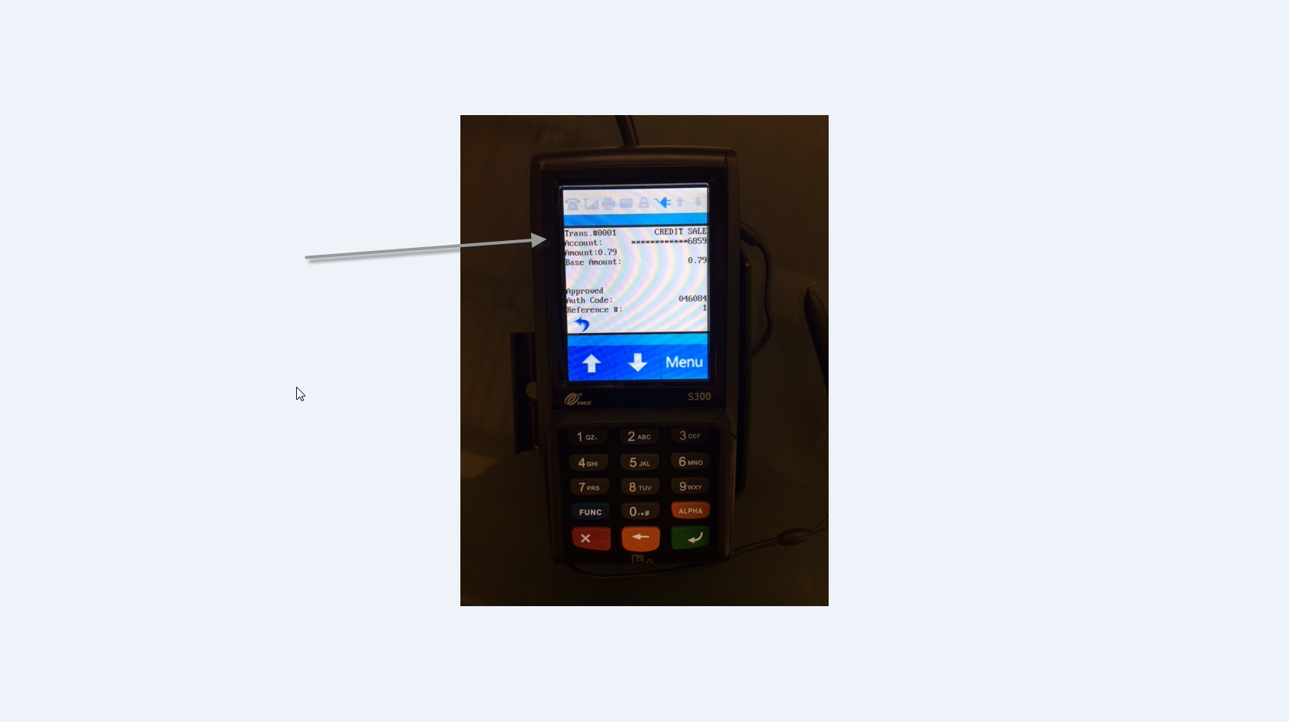
Once viewing is complete press the red X button 3 times until you go to the normal screen.
To verify the number and amount of credit card transactions for that day use either the Daily Sales Report or the Media Tendered Report button found on the first report page. For the Media Tendered Report uncheck all boxes except for credit cards, and then click OK. The detail report for credit cards will appear

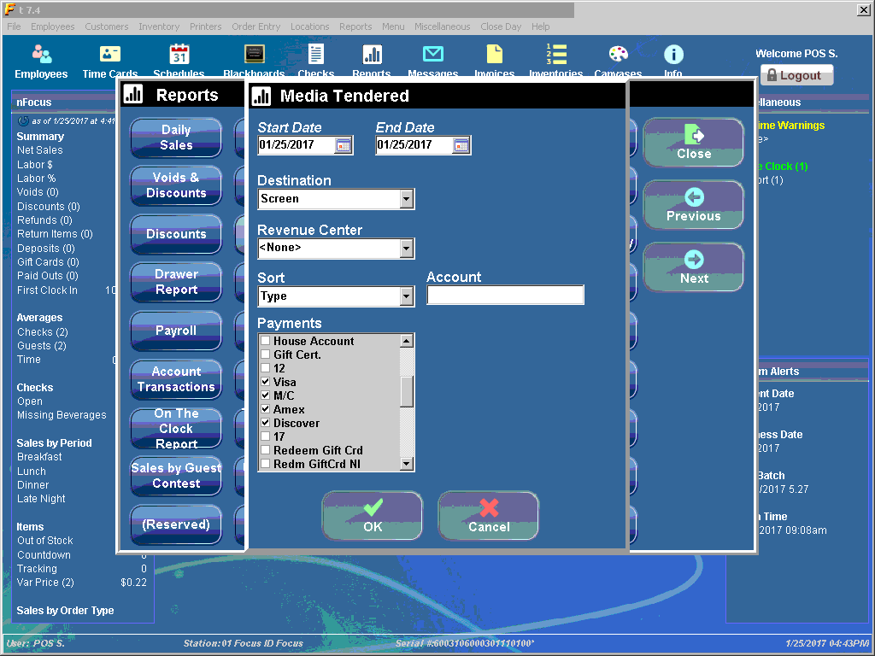

Below is what is the Daily Sales Report will resemble, it will display the credit card summary of transactions.
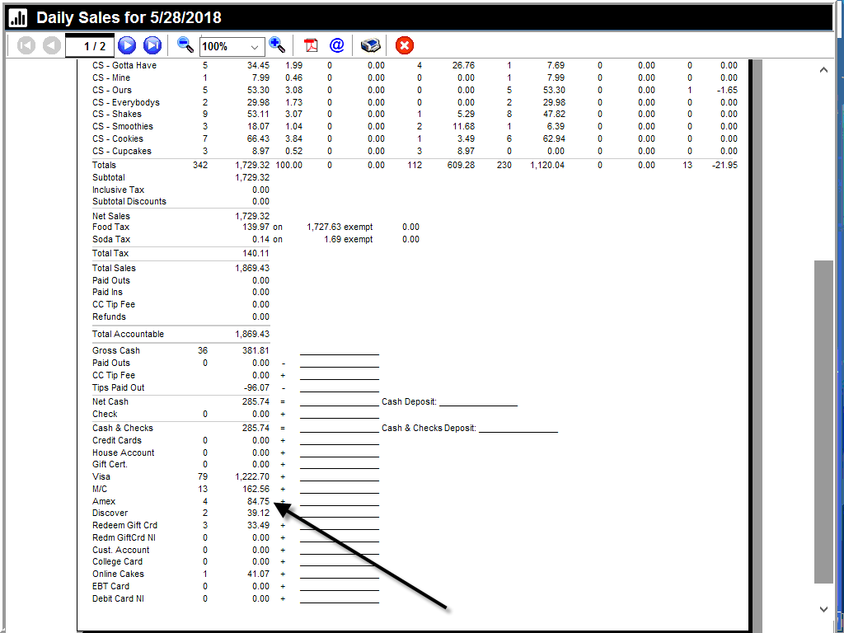

In order to see a more detailed report of your credit card transactions, you will view the Media Tendered report for that day.

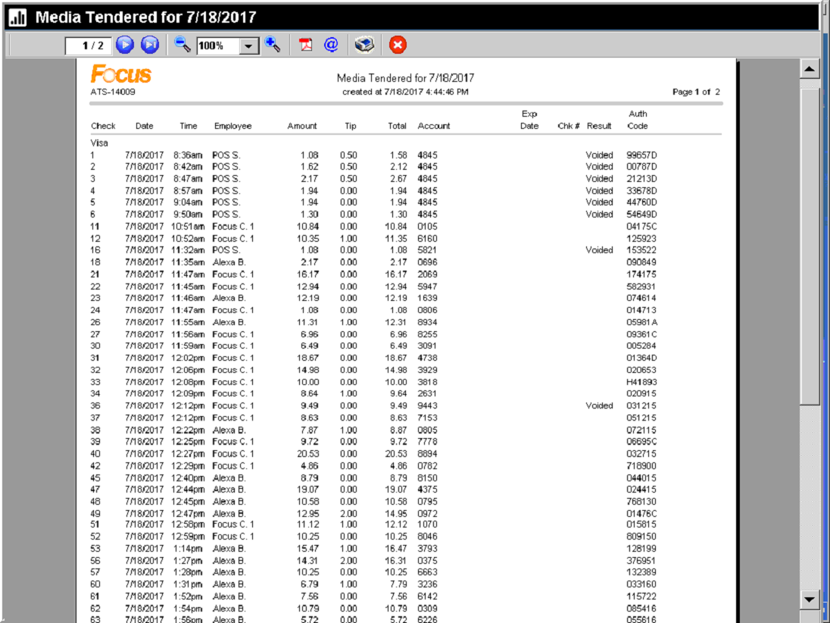

The Daily Sales Report and the Media Tendered report will be the only location to see the summary of credit card transactions for the day on Focus. However, it is recommended that you have an online ClientLine setup for your First Data account. This allows you to reconcile your credit card transactions with the Media Tendered Report in Focus.
If you have any further questions in regards to the PAX and credit card processing please contact Jerry Somerville-Shull at the Helpdesk 1-877-811-3811.

Pax S300 FAQs

EMV Refunds are handled in multiple ways:
- How can I perform a refund? The store can refund the customer if the transaction is in the same day through Focus.
- Is there another form of refund other than cash? The store can issue a store gift card.
- Can I refund the credit transaction from a previous day? If the credit transaction is from a previous day then the credit card processor will need to be contacted. You will need the following information: customer card number, name on the credit card, expiration date, amount of the transaction, and the date the transaction occurred.
- Does the new EMV reader ask if the customer is using debit or credit? No cards automatically process as credit. However, some EMV cards require a PIN which can be entered or by passed by processing the green enter button.
- How does a cashier know if a tip is added by the customer? The amount of the ticket will update with tip once receipt is printed. Also, tip will display on the Media Tender Report for that day.
- Does the new device automatically issue a paper receipt? Yes, Focus will print a detailed transaction receipt and credit card signature receipt.
- Does the Customer still sign the receipt? Yes, customer does sign the credit card receipt.
- Are printed receipts automatic or a choice? Detailed receipts are a choice for now; however, once Spendgo program rolls out nationally all detailed receipts will be required to print.
- Will the register still have a swipe option, or is it all one way or the other? The Pax S300 has a chip reader and swipe. It also allows for manual entry if EMV chip card is malfunctioning. The Pax terminal also allows wireless NFC (Near Field Communications) via an iPhone Pay and Samsung Pay
- What happens if I lose internet? Will my Pax terminal still function? The answer is “NO.” Since this is an EMV secure device it requires a constant uninterrupted high speed internet connection. However, if you have a Cybera Device with 3G \ 4G wireless backup option you will be able to process credit cards if your internet goes down.
- What if I want to change from Pax processing to back to Focus integrated credit card processing can I do it? The answer is yes; however, since Pax requires a modified Focus key to switch back to Focus integrated credit cards will require another Focus key change that will cost $250.
- Can a tip be added to the transaction after it is closed out in Pax? The answer is no… This is the reason the transaction is secured and complies with PCI policies since it cannot be altered after the transaction is closed.
- Why can’t I void some debit vs. credit card transactions? Since the Pax S300 is a secure PCI device, First Data runs transaction sweeps multiple times during the day. All debit card transactions that are processed on the Pax in that time window have approximately 25 min. that the debit transaction can be voided. Otherwise, the transection can only be refunded with cash (in the same day after transaction sweep) or refunded the next day, when the transaction is settled by First Data. Stores would have to call First Data to refund the debit transaction the following day.

